Bitwise Operations and Functions in Python: Payroll access Management System

Student Name: Davis Musungu Chenge
Student ID: SKH-2026-0101
Course: Python Programming
Unit: Bitwise Operations and Functions in Python
Trainer: Mahmoud Kenty
Date: 10th Aug 2026

1. Introduction
Payroll information contains sensitive details such as salaries, deductions, and other employee information. For this reason, employees should not all have the same level of access to payroll systems. Permissions need to be granted depending on the roles served by the different staff handling the payroll, for example, a payroll clerk may need to enter payroll information, while a payroll manager may also need to approve payroll. A payroll administrator may require access to all payroll functions.
This project demonstrates the application of Python bitwise operations and functions by developing a simple payroll access management system for a small business. The system uses different permission levels to control access to payroll activities such as viewing payroll, entering payroll information, approving payroll, managing payroll, and generating reports.
Bitwise operations work directly with the individual bits that make up an integer. Python provides several bitwise operators, including AND (&), OR (|), XOR (^), and bit-shifting operators such as left shift (<<) and right shift (>>). These operations can be useful when several Boolean permissions need to be stored efficiently in a single integer.
The program also demonstrates the use of user-defined functions. Functions allow a program to be divided into smaller sections that perform specific tasks. They can receive parameters and return values, making the program easier to organize and reuse. In this project, functions are used for validating employee names, assigning permissions, checking permissions, toggling permissions, and displaying employee permissions.

2. Program Design
The payroll access management system represents each permission using a different bit position. Five permissions are defined in the program:
Permission | Python Definition | Value | Binary
View Payroll | 1 << 0 | 1 | 00001
Enter Payroll | 1 << 1 | 2 | 00010
Approve Payroll | 1 << 2 | 4 | 00100
Manage Payroll | 1 << 3 | 8 | 01000
Generate Reports | 1 << 4 | 16 | 10000
The left-shift operator is used to place each permission into a different bit position. This means that several permissions can be combined into one integer without losing information.
Flow chart:
Payroll clerk:
- Enters Payroll
- Views Payroll
- Generates reports

Payroll is sent to Payroll Manager for approval

Payroll Manager:
-Eenters payroll
- Views payroll
- Approves payroll
-Generates reports

Forwards payroll to Administrator for final approvals and execution

Payroll Administrator can:
- Enter Payroll
-View payroll
-Approve Payroll
-Manage payroll
- Generate report
-

The program provides three employee roles: Payroll Clerk, Payroll Manager, and Payroll Administrator. Each role receives a different combination of permissions. The OR (|) operator is used to combine the individual permission flags. For instance the Payroll Manager receives View Payroll, Enter Payroll, Approve Payroll, and Generate Reports permissions. These permissions are combined using OR.
The program follows the following sequence:
- The program displays the Mavuno Sacco payroll access management system.
- The user enters an employee name.
- The name is validated using the validate_name() function.
- The user selects an employee role.
- The get_role_permissions() function assigns permissions based on the selected role.
- The program displays the employee's permission value and binary representation.
- The display_permissions() function displays the employee's individual permissions.
- The AND (&) operator is used to check specific permissions.
- The XOR (^) operator is used to demonstrate toggling the Generate Reports permission.
- The right-shift (>>) operator is used to demonstrate shifting the permission bits.
- The program displays a successful completion message.

3. Code Implementation
The following is the final Python implementation used for the project.
# Payroll Access Management System
# Bitwise Operations and Functions
# Permission Flags
VIEW_PAYROLL = 1 << 0
ENTER_PAYROLL = 1 << 1
APPROVE_PAYROLL = 1 << 2
MANAGE_PAYROLL = 1 << 3
GENERATE_REPORTS = 1 << 4

def validate_name(name):
"""Validate the employee name."""
return len(name.strip()) >= 2

def get_role_permissions(role):
"""Return permissions based on the employee's role."""

if role == "1":
# Payroll Clerk
permissions = (
VIEW_PAYROLL
| ENTER_PAYROLL
| GENERATE_REPORTS
)
return permissions

elif role == "2":
# Payroll Manager
permissions = (
VIEW_PAYROLL
| ENTER_PAYROLL
| APPROVE_PAYROLL
| GENERATE_REPORTS
)
return permissions

elif role == "3":
# Payroll Administrator
permissions = (
VIEW_PAYROLL
| ENTER_PAYROLL
| APPROVE_PAYROLL
| MANAGE_PAYROLL
| GENERATE_REPORTS
)
return permissions

else:
return 0

def check_permission(permissions, permission):
"""Check whether an employee has a particular permission."""
return (permissions & permission) != 0

def toggle_permission(permissions, permission):
"""Toggle a permission using XOR."""
return permissions ^ permission

def display_permissions(permissions):
"""Display all permissions assigned to an employee."""

permission_list = {
VIEW_PAYROLL: "View Payroll",
ENTER_PAYROLL: "Enter Payroll",
APPROVE_PAYROLL: "Approve Payroll",
MANAGE_PAYROLL: "Manage Payroll",
GENERATE_REPORTS: "Generate Reports"
}

print("\nEmployee Permissions:")

for permission, name in permission_list.items():
if check_permission(permissions, permission):
print(f"- {name}")

def main():

print("======================================")
print(" MAVUNO SACCO PAYROLL")
print(" ACCESS MANAGEMENT SYSTEM")
print("======================================")

name = input("\nEnter employee name: ")

if not validate_name(name):
print("Invalid name. Please enter at least 2 characters.")
return

print("\nSelect employee role:")
print("1. Payroll Clerk")
print("2. Payroll Manager")
print("3. Payroll Administrator")

role = input("Enter role number: ")

permissions = get_role_permissions(role)

if permissions == 0:
print("Invalid role selected.")
return

print("\n======================================")
print(" EMPLOYEE ACCESS DETAILS")
print("======================================")

print(f"Employee: {name}")
print(f"Permission value: {permissions}")
print(f"Binary representation: {permissions:05b}")

display_permissions(permissions)

print("\n======================================")
print(" PERMISSION CHECKS")
print("======================================")

if check_permission(permissions, APPROVE_PAYROLL):
print("APPROVE PAYROLL: Allowed")
else:
print("APPROVE PAYROLL: Not allowed")

if check_permission(permissions, GENERATE_REPORTS):
print("GENERATE REPORTS: Allowed")
else:
print("GENERATE REPORTS: Not allowed")

print("\n======================================")
print(" XOR DEMONSTRATION")
print("======================================")

original_report_access = check_permission(
permissions,
GENERATE_REPORTS
)

if original_report_access:
print("Original Generate Reports permission: ENABLED")
else:
print("Original Generate Reports permission: DISABLED")

print("\nApplying XOR to toggle Generate Reports permission...")

new_permissions = toggle_permission(
permissions,
GENERATE_REPORTS
)

new_report_access = check_permission(
new_permissions,
GENERATE_REPORTS
)

if new_report_access:
print("After XOR: Generate Reports is ENABLED.")
else:
print("After XOR: Generate Reports is DISABLED.")

print("\n======================================")
print(" RIGHT SHIFT DEMONSTRATION")
print("======================================")

shifted_value = permissions >> 1

print(f"Original permission value: {permissions}")
print(f"Original binary value: {permissions:05b}")
print(f"\nAfter shifting right by 1 bit: {shifted_value}")
print(f"Shifted binary value: {shifted_value:05b}")

print("\n======================================")
print(" COMPLETED SUCCESSFULLY")
print("======================================")

main()

4. Explanation of the Code

Permission Flags and Left Shifting
The program begins by defining the five payroll permissions:
VIEW_PAYROLL = 1 << 0
ENTER_PAYROLL = 1 << 1
APPROVE_PAYROLL = 1 << 2
MANAGE_PAYROLL = 1 << 3
GENERATE_REPORTS = 1 << 4
The left-shift operator (<<) moves the binary value 1 to a specific position. For example:
1 << 0 = 00001
1 << 1 = 00010
1 << 2 = 00100
1 << 3 = 01000
1 << 4 = 10000
This is important because each permission has a unique bit. As a result, several permissions can be combined into a single integer.

Bitwise OR
The OR operator (|) is used to combine permissions.
For example, a Payroll Clerk receives:
permissions = (
VIEW_PAYROLL
| ENTER_PAYROLL
| GENERATE_REPORTS
)
The binary values are:
00001
00010
10000
-----
10011
The resulting value is 19.
The OR operation is therefore useful in this system because it allows the program to combine multiple permissions into one permission value.

Bitwise AND
The AND operator (&) is used by the check_permission() function:
def check_permission(permissions, permission):
return (permissions & permission) != 0
Its purpose is to check whether a particular permission exists.
For example, if an employee has:
10011
and the program checks Generate Reports:
10011
&
10000
-----
10000
The result is not zero, so the employee has Generate Reports permission.
This operation is important because the program can check individual permissions without having to store each permission in a separate variable.

Bitwise XOR
The XOR operator (^) is used in the toggle_permission() function:
def toggle_permission(permissions, permission):
return permissions ^ permission
XOR is different from AND. It is used to toggle a bit.
If the bit is 1, XOR with 1 changes it to 0. If the bit is 0, XOR with 1 changes it to 1.
For example:
10011
^10000
-----
00011
Here, Generate Reports changes from enabled to disabled.
The program first checks the employee's actual Generate Reports permission. It then applies XOR and checks the permission again. This makes the purpose of XOR clear.
The importance of XOR in this system is that it provides a simple way to demonstrate how an access flag can be switched between enabled and disabled states. The original permissions variable is not changed; instead, the toggled value is stored in new_permissions.

Right Shift
The program also uses the right-shift operator:
shifted_value = permissions >> 1
A right shift moves the binary bits one position to the right.
For example:
Original: 10011
Right >>1: 01001
The decimal value changes from 19 to 9.
The right shift is included mainly to demonstrate the bit-shifting requirement of the assignment. In a larger permission system, shifting can also be used when processing or examining individual bit positions.

Functions, Parameters, and Return Values
The program contains five user-defined functions.
The validate_name() function accepts the employee's name as a parameter and returns either True or False.
The get_role_permissions() function accepts the employee's role and returns an integer containing the employee's permissions.
The check_permission() function accepts two parameters: the complete permission value and the specific permission being checked. It returns a Boolean value.
The toggle_permission() function also accepts two parameters and returns a new permission value after applying XOR.
Finally, display_permissions() accepts the permission value and uses it to display the permissions assigned to the employee.
The functions interact with each other through parameters and return values. For example, main() receives the employee's role, passes it to get_role_permissions(), receives the resulting permission value, and then passes that value to other functions.

5. Output Evidence
See below screenshots:
Figure 1:
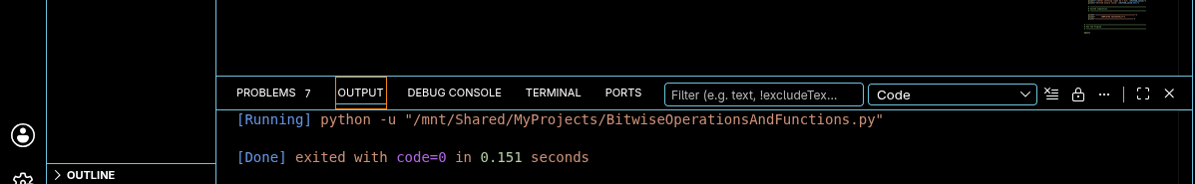
Figure 2:
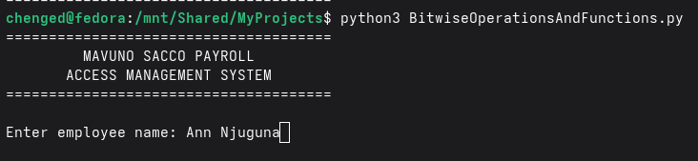
Figure 3:
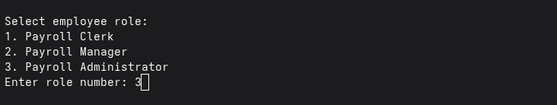

Figure 4:
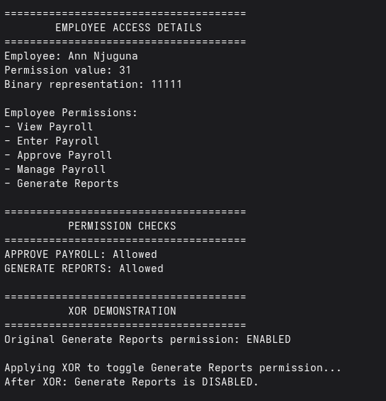
Figure 5:
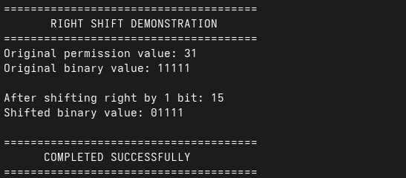
The statement "GENERATE REPORTS: Allowed" represents the employee's actual permission. The later statement "After XOR: Generate Reports is DISABLED" represents the result of deliberately toggling that permission using XOR. These are different operations and should not be interpreted as contradictory results.

6. Conclusion
This project demonstrated how Python bitwise operations and functions can be applied to a practical payroll access management scenario. The program represents five different payroll permissions as individual bits within an integer. This makes it possible to store and process multiple permissions using a single value.
The OR operator was used to combine permissions, while the AND operator was used to check whether an employee had a particular permission. XOR was used to demonstrate how a permission can be toggled between enabled and disabled states. The left-shift operator was used to create the individual permission flags, while the right-shift operator demonstrated how binary values can be moved between bit positions.
The project also improved my understanding of Python functions. Functions made the program easier to organize because each function had a specific responsibility. Parameters allowed information to be passed into functions, while return values allowed results to be passed back to other parts of the program.
One challenge was understanding why the original XOR output showed that Generate Reports was disabled even when the employee had that permission. The problem was not a Python error. XOR intentionally changes a bit from 1 to 0 when it is XOR-ed with another 1. The solution was to check and display the employee's original permission separately before demonstrating XOR. This made the program's output clearer and demonstrated the difference between checking a permission with AND and toggling a permission with XOR.
Although this is a simplified payroll system, the project demonstrates an important programming concept that can be applied to real software systems. A production payroll application would require additional security features such as authentication, authorization controls, secure databases, encryption, audit logging, and appropriate protection of employee information. Nevertheless, this project provides a useful demonstration of how bitwise operations and functions can work together in a practical application.

7. References
Python Software Foundation. (2026). Built-in types. Python Documentation. https://docs.python.org/3/library/stdtypes.html
Python Software Foundation. (2026). Defining functions. Python Documentation. https://docs.python.org/3/tutorial/controlflow.html#defining-functions
Python Software Foundation. (2026). Expressions. Python Documentation. https://docs.python.org/3/reference/expressions.html

